-- Q1

select CompanyName, Country from hwsuppliers

where Country = 'Japan' || Country = 'Germany'

order by Country, CompanyName;

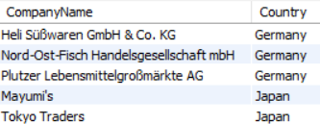

-- Q2

select ProductName, QuantityPerUnit, UnitPrice from hwproducts

where UnitPrice > 4 && UnitPrice < 7

order by ProductName;



-- Q3

select CompanyName, City, Country from hwcustomers

where (Country = 'USA' && City = 'Portland') || (Country = 'Canada' && City = 'Vancouver')

order by CompanyName;

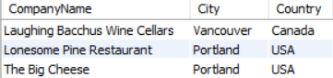

-- Q4

select ContactName, ContactTitle from hwsuppliers

where SupplierID >= 5 && SupplierID <= 8

order by ContactName;

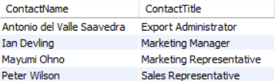

-- Q5

select ProductName, UnitPrice from hwproducts

where ProductID in(

select ProductID from hwproducts

where UnitPrice in(

select min(UnitPrice) from hwproducts

)

);



-- Q6

select ShipCountry, count(OrderID) as OrderCount from hworders

where ShipCountry != 'USA' && ShippedDate > '20150504' && ShippedDate < '20150510'

group by ShipCountry

having OrderCount > 3

order by OrderCount;



-- Q7

select FirstName, LastName, Date_Format(HireDate, '%m/%d/%Y') as HireDate from hwemployees

where Country != 'USA' && datediff(current_date(), HireDate) >= 1825

order by concat(FirstName, ' ', LastName);

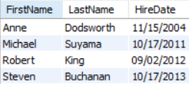

-- Q8

select ProductName, (UnitsInStock*UnitPrice) as InventoryValue from hwproducts

where (UnitsInStock*UnitPrice) > 3000 && (UnitsInStock*UnitPrice) < 4000

order by InventoryValue desc;

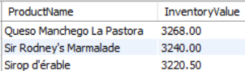

-- Q9

select ProductName, UnitsInStock, ReorderLevel from hwproducts

where LEFT(ProductName, 1) = 'S' && UnitsInStock > 0 && UnitsInStock <= ReorderLevel

order by ProductName;



-- Q10

select ProductName, UnitPrice, QuantityPerUnit from hwproducts

where Discontinued = 1

order by ProductName;

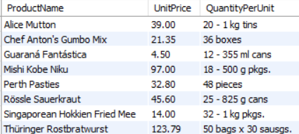

-- Q11

select ProductName, (UnitPrice*UnitsInStock) as InventoryValue from hwproducts

where SupplierID in(

select SupplierID from hwsuppliers

where Country = 'Japan'

)

order by InventoryValue desc;

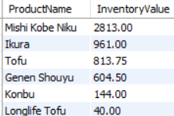

-- Q12

select Country, count(CustomerID) as Count from hwcustomers

group by Country

having Count > 8;

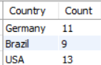

-- Q13

select ShipCountry, ShipCity, count(OrderID) as OrderCount from hworders

where ShipCountry = 'Austria' || ShipCountry = 'Argentina'

group by ShipCountry, ShipCity

order by ShipCountry, ShipCity;

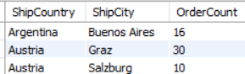

-- Q14

select CompanyName, ProductName

from hwsuppliers

inner join hwproducts on hwsuppliers.SupplierID = hwproducts.SupplierID

where Country = 'Spain';

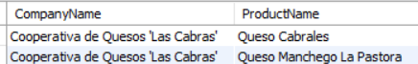

-- Q15

select round(avg(UnitPrice), 2) as 'Average Unit Price' from hwproducts

where right(ProductName, 1) = 'T';



-- Q16

select concat(FirstName, ' ', LastName) as 'Full Name', Title, count(OrderId) as 'OrderCount'

from hwemployees

inner join hworders on hwemployees.EmployeeID = hworders.EmployeeID

group by concat(FirstName, ' ', LastName), Title

having OrderCount > 120;

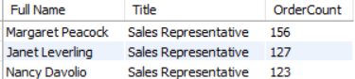

-- Q17

select CompanyName, Country

from hwcustomers as c

where (select count(OrderID) from hworders

where CustomerID = c.CustomerID)=0;

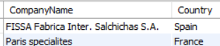

-- Q18

select ProductName, CategoryName

from hwcategories

inner join hwproducts on hwproducts.CategoryID = hwcategories.CategoryID

where UnitsInStock = 0;

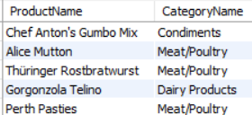

-- Q19

select ProductName, QuantityPerUnit

from hwproducts

inner join hwsuppliers on hwproducts.SupplierID = hwsuppliers.SupplierID

where Country = 'Japan' &&

(QuantityPerUnit like '%pkg%' ||

QuantityPerUnit like '%pkgs%' ||

QuantityPerUnit like '%jars%');

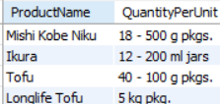

-- Q20

select CompanyName, ShipName,

(select round(sum((UnitPrice*Quantity*(1-Discount))), 2) as OrderValue

from hworderdetails

where OrderId = hworders.OrderID) as OrderValue

from hwcustomers

inner join hworders on hwcustomers.CustomerID = hworders.CustomerID

where Country = 'Mexico';

select CompanyName, ShipName, round(sum((UnitPrice*Quantity*(1-Discount))), 2) as OrderValue

from hwcustomers

inner join hworders on hwcustomers.CustomerID = hworders.CustomerID

inner join hworderdetails on hworders.OrderID = hworderdetails.OrderID

where Country = 'Mexico'

group by CompanyName, ShipName

order by CompanyName;

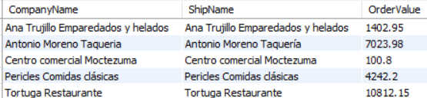

-- Q21

select ProductName, Region

from hwproducts as p

inner join hworderdetails as od on p.ProductID = od.ProductID

inner join hworders as o on od.OrderID = o.OrderID

inner join hwcustomers as c on o.CustomerID = c.CustomerID

where right(ProductName, 1) = 'L' && Region != ''

order by ProductName;

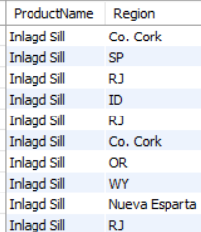

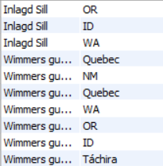



-- Q22

select ShipCountry, ShipName, date_format(OrderDate, '%M %Y') as OrderDate

from hworders

where ShipCity = 'Versailles' &&

CustomerID not in(

select CustomerID

from hwcustomers);

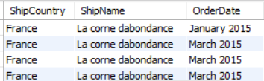

-- Q23

select ProductName, UnitsInStock, row_number()over(order by UnitsInStock desc) as 'Rank'

from hwproducts

where left(ProductName, 1) = 'F'

order by UnitsInStock desc;

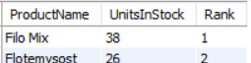

-- Q24

select ProductName, UnitPrice, row_number()over(order by UnitPrice) as 'Rank'

from hwproducts

where ProductID >= 1 && ProductID <= 5;

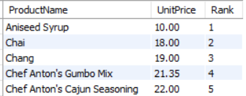

-- Q25

select FirstName, LastName, Country, date_format(BirthDate, '%m/%d/%Y') as DateOfBirth, row_number()over(partition by Country order by BirthDate) as 'Rank'

from hwemployees

where year(BirthDate) > 1984

group by Country, FirstName, LastName, BirthDate

order by Country, BirthDate;

